- \Operation\Robot\General
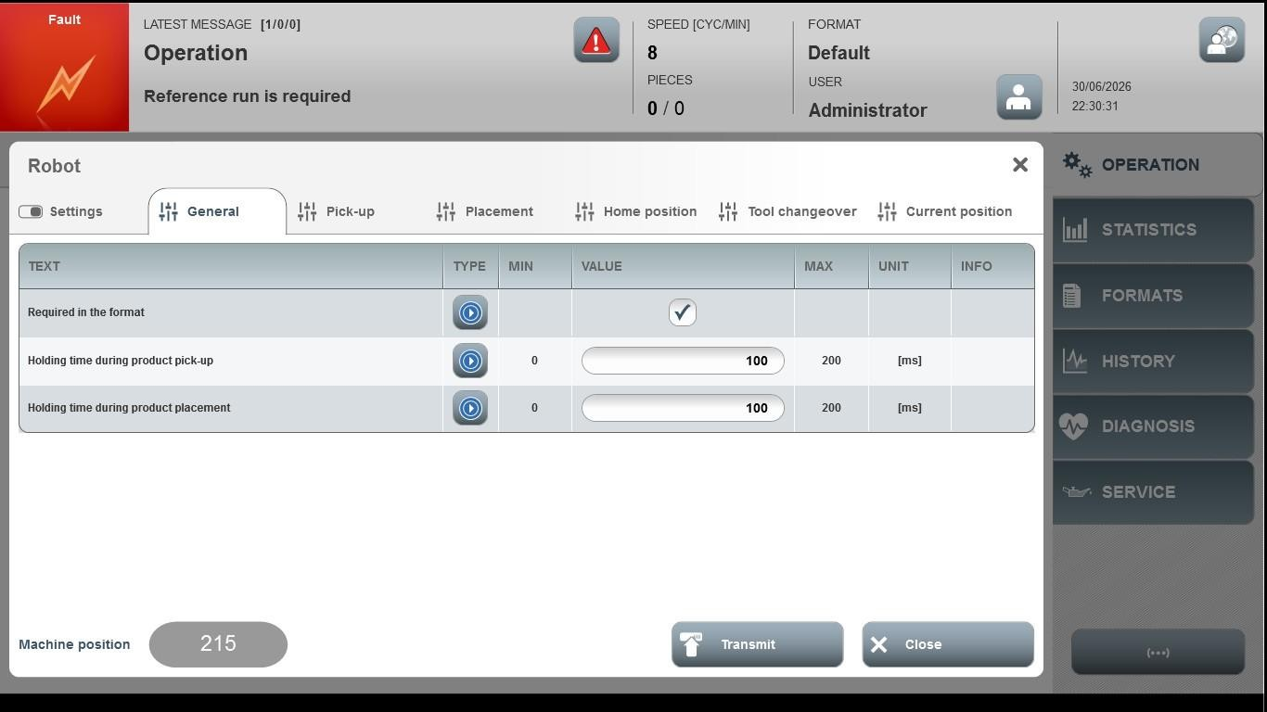
Acceptance criterion | Limits | Pass / Fail: Dev-No. | Date | Initials
Screen matches screenshot | N / A
Robot Speed | 10…35
Additional Placing Time | 0.00…5000.00
Prerun Correction Vacuum Off | 0.00…50.00
Holding Time During Product Pick-Up | 0 … 1000
Holding Time During Product Placement | 0 … 1000

